Testing “www.imdb.com” Using Selenium IDE

Charlotte Chen & Daniel Hui

CS 1632 – DELIVERABLE 3: Web Testing with BDD

====================================================================

**Summary:**

Our group decided to test the website *www.imdb.com* because it is the top site where people go to search for movie information, so everyone (including us) are familiar with the features of the site. It makes our testing more accurate because when writing our JUnit tests, we will have in mind of the the expected behaviors after certain actions. Consequently, it will also be easier for reviewers of our test, since they are also familiar with the behavior of the website.

Moreover, *www.imdb.com* is fairly straightforward in terms of its structure and functionalities. It includes common features such as login, rating, sorting, searching, and commenting, which are all basic features existing in nowadays sites that are reasonable and important to test. More specifically, the website is fairly interactive since users have the options to register and contribute to the site by rating and posting, and we found these interactive features to be worthy to test. At the same time, the interactivity is not so complicated in comparison to social media sites like *www.facebook.com*, whereby reducing abnormal issues that might arise when we perform tests.

**Issues:**

(1) When testing a text element with whitespace after it using the assertText command on Selenium IDE, it was difficult to notice that our input text has a blank space after it. Thus, assertText kept failing when we tried to use the command to check “Passwords must match ” (not trimmed) against the actual value “Passwords must match” (trimmed whitespace).

(2) We tried to test the movie rating feature of the website, which is a feature that requires users to log in. However, when we performed a JUnit test (testing that a movie will display on a user’s personal rating page after they rate the movie), the test would fail midway at locating the rating div. We then realized that every time the firefox browser launches during test we are logged out as users, which is why the test is unable to locate the div containing the editable rating bar accessible only to logged-in users. Our initial attempt was to set “logged-in” as a precondition (by writing it in @Before) in our JUnit test, then we quickly realized that it is not possible because IMDB implements CAPTCHA during log in to prevent “bots” like Selenium from automatically logging users in. We had to give up testing the rating functionality.   
  
  
**Git Repository:** https://github.com/charlottechen1993/CS1632-Deliverable3

**Screenshots:**

User Story 1: Registration:

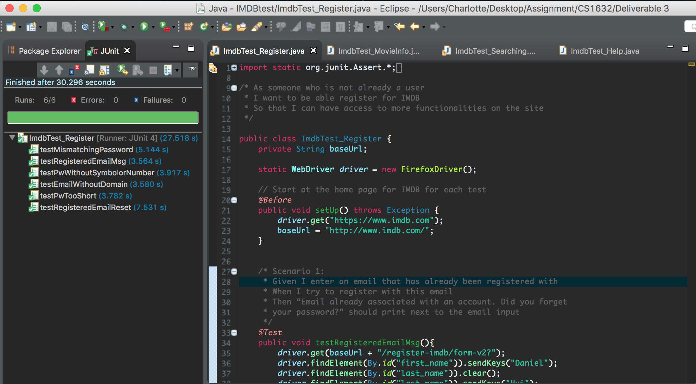

User Story 2 – Help Information

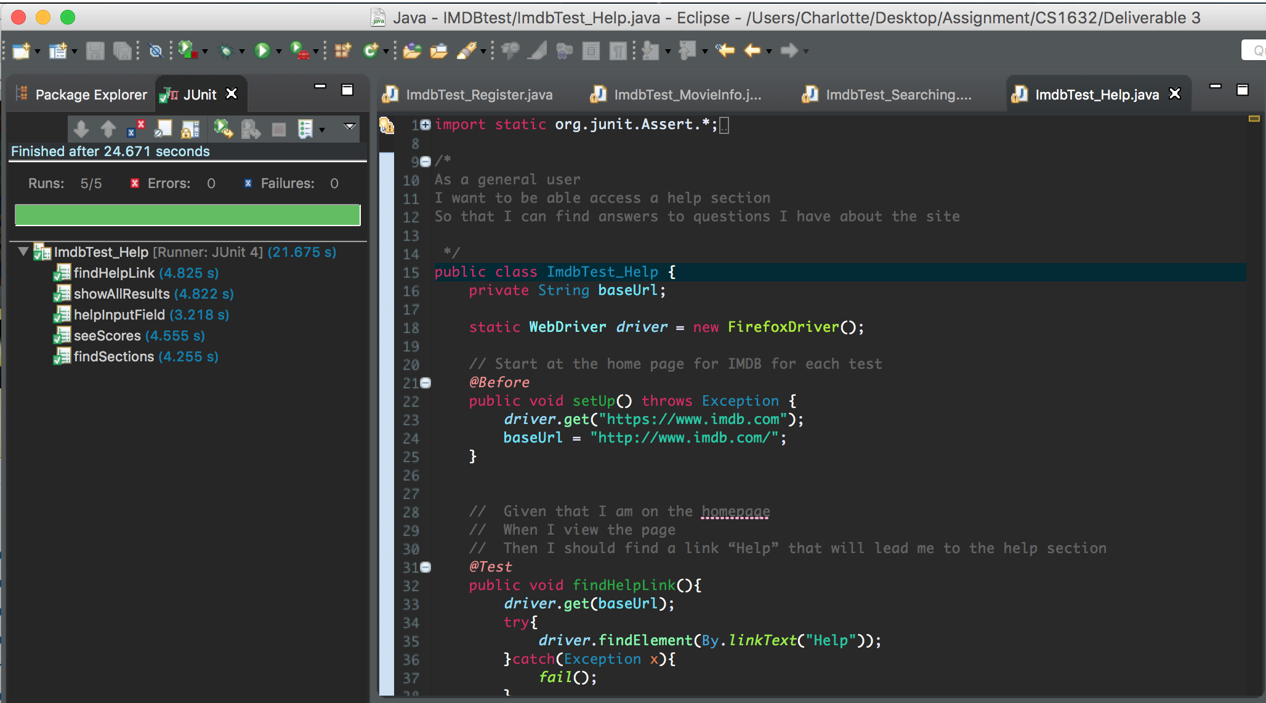

User Story 3 – Movie Information

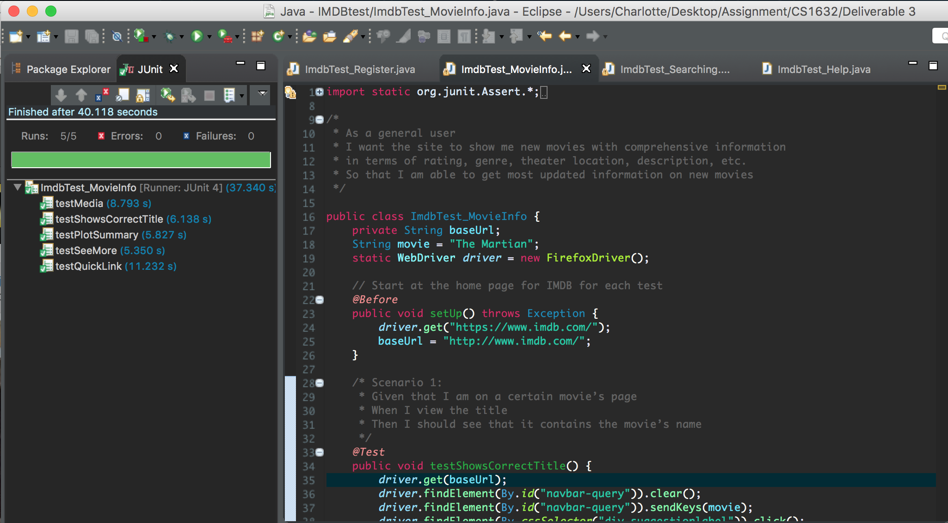

User Story 4 – Searching

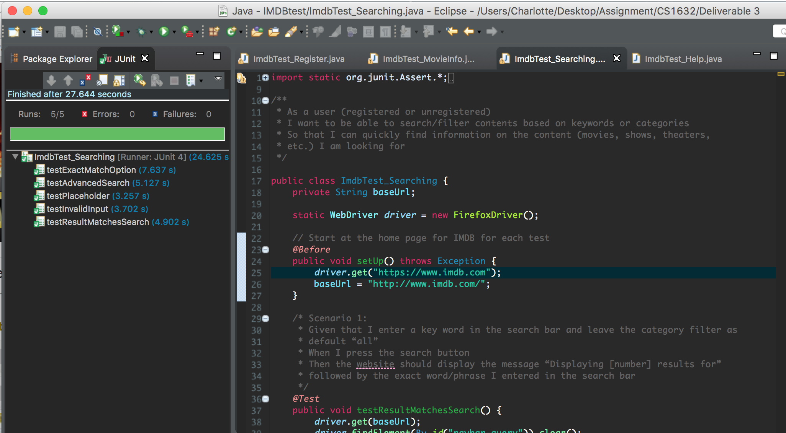

**User Story 1 - Registration**

As someone who is not already a user

I want to be able to register for IMDB

So that I can have access to more functionalities on the site

====================

Scenario 1:

Given I enter an email that has already been registered with

When I try to register with this email

Then “Email already associated with an account. Did you forget your password?” should print next to the email input

Scenario 2:

Given that I enter an email that has already been registered with

When I try to register with that email

Then site will assume that I forgot my password and give me the opportunity to reset my password

Scenario 3:

Given I enter mismatching passwords

When I try to register with these passwords

Then “Passwords must match” should print next to the password input

Scenario 4:

Given I enter a password that does not include a symbol

When I try to register with this password

Then “Password must contain numbers or symbols” should print next to the password input

Scenario 5:

Given I enter an email without a domain(gmail.com,hotmail.com,pitt.edu)

When I try to register with this email

Then “Please supply a valid email” should print next to the email input

Scenario 6:

Given I enter a password less than 8 characters

When I try to register with this password

Then ”Password must be at least 8 characters” should print next to the password input

**User Story 2 – Help Information**

As a general user

I want to be able to access a help section

So that I can find answers to questions I have about the site

====================

Scenario 1:

Given that I am on the homepage

When I view the page

Then I should find a link “Help” that will lead me to the help section

Scenario 2:

Given that I click on “Help” and is linked to the help page

When I view the page

Then I should find sections titled “Top Frequently Asked Questions” and “Help Sections/FAQs”

Scenario 3:

Given that I am on the help page

When I view the page

Then I should be able to find a “Search Help” input field where I can search questions by inputting keywords

Scenario 4:

Given that I perform a search via the “Search Help” bar and there are results that matches my search

When I view the result page

Then I should be able to see a “Score” followed by a number next to each search result that informs me of their helpfulness

Scenario 5:

Given that I perform a search via the “Search Help” bar and the results that matches my search exceeds 5

When the page loads the top 5 questions that are related to my search

Then the page should also display a “Show all results” button that gives me the option to see all results

**User Story 3 – Movie Information**

As a general user

I want to see comprehensive information on each individual movie’s page in forms of text, links, videos, comments, or images

So that I can understand the movie better

====================

Scenario 1:

Given that I am on a certain movie’s page

When I view the title

Then I should see that it contains the movie’s name

Scenario 2:

Given that I search for a certain movie

When the page on the movie loads

Then I should be able to easily navigate to the movie’s plot, reviews, or award sections via quick links

Scenario 3:

Given that the I am on a certain movie’s page

When I navigate to the Storyline section

Then I should have the option to see both “Plot Summary” and “Plot Synopsis”

Scenario 4:

Given that the I am on a certain movie’s page

When I navigate to “Details”

Then I should have the option to see more than the basic information displayed on the current page via a “See more” link and also be warned of potential spoilers

Scenario 5:  
Given that I search for a certain movie

When the page on the movie loads

Then I should have the option to quickly navigate to separate pages via links to see only photos, videos, and articles related to the movie

**User Story 4 – Searching**

As a general user

I want to be able to search/filter contents based on keywords or categories

So that I can quickly find information on my search interests (e.g. movies, shows, theaters, etc.)

====================

Scenario 1:  
Given that I enter a key word in the search bar and leave the category filter as default “all”

When I press the search button

Then I should see the website display the message “Displaying [number] results for” followed by the exact word/phrase I entered in the search bar

Scenario 2:  
Given that I enter a key word in the search bar and select “title” from the dropdown

When I press the search button and the website displays the list of results that contains the word/phrase that I input

Then I should be given the option to further filter the result to match exactly to my search by clicking the link “Exact title matches”

Scenario 3:

Given that I am on the homepage

When I navigate to the search bar

Then I should see the message “Find Movies, TV Shows, Celebrities and more...” in the search bar informing me my search options

Scenario 4:

Given that I enter an invalid input (e.g. symbols, long numbers, or long strings) into the search bar that will return no results

When I press the search button

Then I should see the website display “No results found for” followed by the input I entered

Scenario 5:

Given that I am on the homepage

When I select/click “Advanced Search” from the bottom of the dropdown menu

Then I should be redirected to a new page with options of “Advanced Title Search”, “Advanced Name Search”, and “Collaborations and Overlaps”